Week 1  Understanding Biomarker Science 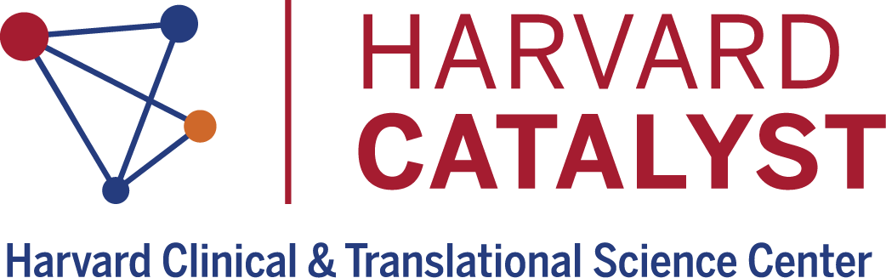  ^{5/7}  FUNDAMENTAL CONCEPTS IN BIOMARKER SCIENCE | 8:00-8:30 AM | Biomarkers in Translational Medicine & Therapeutics
 | 8:45-9:15 AM | Valuing the Importance of Participants and Patients: Ethical Conduct of Research
 | 9:30-10:00 AM | Imaging and Biomarkers
 | 10:15-10:45 AM | FDA & Biomarkers
Week 2  ^{5/10 & 5/14}  “HOW-TO” ADVANCE BIOMARKER RESEARCH | 8:00-8:30 AM | Trial Design Basics: COVID
 | 8:45-9:15 AM | How to Quantify Imaging Biomarkers
 | 9:30-10:00 AM | How to Avoid Irreproducibility of Biomarkers
 | 5/10 10:15-11:15 AM  5/14- 10-11 AM | How to Evaluate Biomarkers
Week 3  ^{5/21}  _{BIOMARKER DISCOVERY} | 8:00-8:30 AM | Genomics
 | 8:30-9:00 AM | Proteomics
 | 9:00-9:30 AM | Metabolomics
 | 9:30-10:00 AM | Radiomics
Week 4  ^{5/24}  _{TYPES OF BIOMARKERS} | 8:00-8:30 AM | Microbiome Biomarkers
 | 8:45-9:15 AM | Mass Spectrometry Imaging
 | 9:30-10 AM | Safety Biomarkers
Week 5  ^{6/4}  BIOMARKERS IN HEALTH AND DISEASE | 8:30-9:00 AM | Biomarkers in Immune-Oncology
 | 9:15-9:45 AM | Using Biomarkers to Understand Complex Diseases
 | 10-10:30 AM | Neuro Biomarkers
Week 6  ^{6/11}  _{BIOMARKER TECHNOLOGIES} | 8:00-8:45 AM | Biomarkers in Liver Disease
 | 9:00- 9:45 AM | CRISPR and Health & Disease
 | 10:00- 10:45 AM | Digital Biomarkers
 | 11:00- 11:45 AM | Nanoscale Technologies
Week 7  ^{6/14}  _{CAREER DEVELOPMENT} | 9-10:30 AM | Panel of Perspectives: VC in biomarkers, Academic, Academic into Industry,  Policy Advisor

